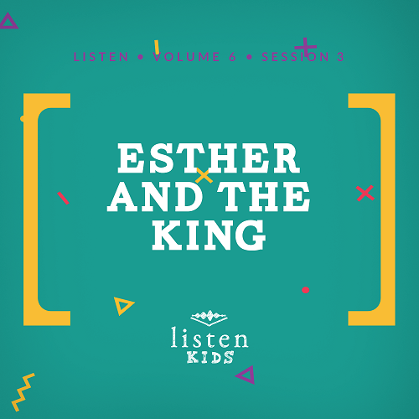
Leader Overview
The story of Esther is always fun as a young woman is the heroine of the story. However, the real hero is God because He put everything together at the perfect time to save His people. When we trust that God knows what’s best, great things can happen. Esther presents an example of God’s divine plans being orchestrated.

Bible Lesson
Esther and the King
Esther 4:10 to 5:4
Faith Fact
God knows what’s best.
Faith Verse
2 Corinthians 5:7 (NLT)
For we live by believing and not by seeing.

Preparing for the Session
Leader Preparation Time: 20–25 Minutesc
You Will Need
Large Group
- Bible
- Worship songs (Song suggestions: “All of Me” by Gateway Kids Worship; “This Is Amazing Grace” by Bethel Music Kids; “It’s Your Love” by Gateway Kids Worship)
- For groups not using a phone or tablet only, add:
• Projector or TV
• Laptop
• Countdown60 Video–60 seconds
• Rules Video or Slide
• Faith Fact Slide
• Faith Verse Video or Slide
• Bible Lesson Video A
• Bible Lesson Video B
• Rolls of toilet paper, three per group
• Chair
• Large Group Bible Story cards
• Optional: Costumes or props for king, queen, guards, royal officials, servants, and townspeople
Small Group
- Small Group Activity Page, one per kid
- Pencils or pens, one per kid
- Small Group Group Connection, one puzzle per kid
- Small Group Faith Verse Review, one set per pair of kids
- Scissors
- Plastic sandwich bags, one per pair

To download session videos, slides, and printables, visit: BibleEngagementProject.com/downloads

Getting Ready
Large Group
- Download videos and slides if needed.
- Select worship song(s) and have them ready to play.
- Print and cut apart the Large Group Bible Story cards.
Small Group
- Print the Small Group Activity Page, one per kid.
- Print and cut apart the Small Group Group Connection page, one puzzle per kid.
- Print and cut apart the words for the Small Group Faith Verse Review, one set per pair.
- Place each set of words in a plastic sandwich bag.

First time leading Listen for Kids? Check out the Facilitator Guide.

Large Group
30 Minutes
See what’s needed at the beginning of the session.

Introduction
We’re so excited you are here! Have you ever wondered what it would be like to be a king or a queen? A scientist or airplane pilot? Have you ever wondered what it would be like to live a completely different life than you are living right now? As fun as those thoughts might be, God has a plan for your life right where you are.
Sometimes we wonder: Why do I live where I do? Or, Why is my family different from your family? God has you exactly where you are for a particular reason or a purpose. You just have to be willing to trust Him.
Let’s take a look at our Faith Fact and say it all together. God knows what’s best.
• Show the Faith Fact Slide.
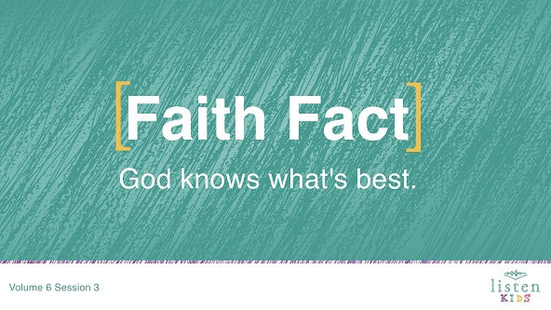

I think we should say it again, but this time let’s say it like we are famous actors in an old British theatre. God knows what’s best. Great job!
Rules Review (Optional)
Wouldn’t it be fun today to do some acting? Well, before we open up the theatre, we need to cover a couple of rules. Let’s take a look at them now.
• Play Rules Video.

Game
Dressed Like Royalty
You Will Need
- Rolls of toilet paper, three per group

No prep needed for this activity.

Today, we are going to be learning about a very important king and queen in the Bible. To help us out we are going to divide the group into a girl group and a boy group. One boy will be the designated “king,” and one girl will be the designated “queen.” You will have one minute to decorate your king or queen the best you can with these three rolls of toilet paper. The leaders will judge who is dressed like royalty when the time’s up.
• Divide the group into smaller groups so more kids can participate.
• Each group should choose their “king” and “queen.”
Ready, set, go!
• Play the Countdown60 Video.
You kids look great. Thank you so much for being willing to play. Now, let’s clean up and take our seats.

Worship
That was a lot of fun! Let’s take some time to worship God before we see how God knows what’s best. Let’s spend some time singing to worship God.
• Lead the kids in singing one or two praise songs. See suggestions at the beginning of the session.

Bible Lesson
That was an incredible time of singing and worshipping God. I am so thankful we can worship together. Can you imagine what it would be like if someone wanted to harm us or even kill us because we worship God? We can praise God that we are safe to worship God. We can thank God that He knows what is best for all of us.
Today, we are going to see how someone wanted to kill God’s chosen people, the Jews, because they were different and worshipped the one true God. One person, a young woman, was given the opportunity to save all of her people. Before we jump into our Bible story, let’s pray together.
Prayer
Dear God, thank You that Your plans are always best, even when we don’t understand. Thank You for protecting us and leading us. Help us learn from Your Word today. Amen.
Video Intro
Let’s check in with the Challenge Accepted team before we look at our Bible story and see what they’re up to!
• Play Bible Lesson Video A.
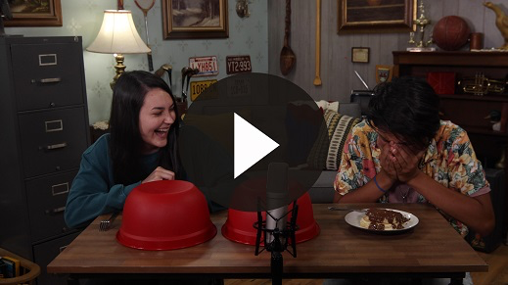
I love pancakes, don’t you? Do you think you could accept the challenge? (Group response) That’s an interesting way to lead-in to our Bible story today!
Bible Story
You Will Need
- Chair
- Large Group Bible Story cards
- Optional: Costumes or props for king, queen, guards, royal officials, servants, and townspeople
Getting Ready
- Print and cut apart the Large Group Bible Story cards

Our story today comes from the Bible Book of Esther. Last time, we talked about how God’s people had been taken captive by the Babylonians and taken to Babylon. Later, the Babylonians were defeated by the Medes and Persians.
After some time a Persian king came to power named Xerxes (ˈzərk-ˌsēz). He needed a new queen and looked all over the kingdom until he found a beautiful young woman named Esther. When Esther was young, she had no idea that one day she would be queen, but God knows what’s best.
Okay, we are going to have some fun today and act out the story with as many of you who want to help as possible. Let’s put a cast together. We need:
• Powerful King Xerxes
• Beautiful Queen Esther
• Sneaky Haman, the bad guy
• Cousin Mordecai
• Servant to Queen Esther
• Guards, servants, and family members as needed in the story
Let’s get everything ready for the story. In the middle of our room is a chair for King Xerxes. (Have king sit in the chair.) Standing beside him is his second-in-command, Haman. Then, we need a couple of guards for the king. (Have Haman and guard move into place.)
• Instruct all actors to do whatever actions you read for their character.
On this side of the room is where the queen lives. She has one personal assistant, or servant, who she trusts no matter what. Then, we need a couple of other servants who help take care of Queen Esther. (Have servants gather around Queen Esther.)
Then, over on this side of the room is Mordecai the Jew, who is well respected by almost all the people. No one knows, but he is a cousin to Queen Esther. In fact, he raised Esther as his own daughter after her parents died. Wave to your cousin, Mordecai! (Have Mordecai and Esther wave to one another.) Everyone else can be the Jewish people who lived in the city of Susa.
The Book of Esther begins with the first queen leaving and Esther becoming queen. Mordecai solved a plot to kill the king and helped to save King Xerxes’s life. Also, Haman was elevated to second in command in the kingdom.
Today, our story begins in Esther 4:10. Haman really thinks he is important and decides that everyone needs to bow to him. After all, he is the second-most powerful and important man in the kingdom. So all the servants and guards bow to him, but Mordecai refuses to bow to him. (Have kids act out.)
Haman gets furious and decides it isn’t enough to punish Mordecai alone. Haman decides to punish all of Mordecai’s people, the Jews. Haman goes to see the king and convinces him to make it a law. The Jews will all be killed! (Have Haman and king act out.)
Mordecai cries out in the streets for God to save them. Esther heard about her cousin and sends her servant to find out what is wrong. (Send the servant across room from Esther to Mordecai and back to Esther.) Mordecai tells the servant about the new law that will kill all the Jews. He asks that the queen go to the king and ask for her people to be saved. The servant runs back and tells the queen.
Esther says, (Have Esther read Esther 1 Card.) “All the king’s officials and even the people in the provinces know that anyone who appears before the king in his inner court without being invited is doomed to die unless the king holds out his gold scepter” (Esther 4:11).
So the servant gives the message to Mordecai.
Mordecai sends this message to Queen Esther, (Have Mordecai read card.) “If you keep quiet at a time like this, deliverance and relief for the Jews will arise from some other place, but you and your relatives will die. Who knows if perhaps you were made queen for just such a time as this?” (Esther 4:14).
Esther responds to Mordecai, (Have Esther read Esther 2 Card.) “Go and gather together all the Jews of Susa and fast for me. Do not eat or drink for three days, night or day … And then, though it is against the law, I will go in to see the king. If I must die, I must die” (Esther 4:16).
Mordecai and all of the Jews prayed and fasted. That means they went without eating so they could spend the time praying. Three days later Esther makes her big move. The servants help her put on her best looking outfit and all the royal robes. Then, she enters into the inner court.
Esther is very nervous and worried because the king hasn’t asked to see her for thirty days. King Xerxes is sitting on his throne. As soon as he sees Queen Esther, he holds out his gold scepter to welcome her in.
King Xerxes says, (Have Xerxes read his card.) “What do you want, Queen Esther? What is your request? I will give it to you, even if it is half the kingdom!” (Esther 5:3).
Esther answers by offering to serve the king a feast before she asks for what she really needs.
Esther requests, (Have Esther read Esther 3 Card.) If it please the king, let the king and Haman come today to a banquet I have prepared for the king” (Esther 5:4).
After a couple of banquets, Esther finally tells the king what is happening to her people, the Jews. King Xerxes has Haman arrested and killed instead. The king gives Queen Esther all of Haman’s property, and she puts Mordecai in charge of the property. The king makes Mordecai his new second-in-command of the kingdom. The king couldn’t change the law about killing the Jews, but he could create a new law that the Jews could defend themselves, which saved all of the Jews.
Teaching Time
No one knew why Esther was chosen to be queen. No one knew why everything happened the way that it did. What we see from this story is that no matter what happens God knows what’s best.
Sometimes God puts us in places that don’t make sense at the time. Maybe you are in a situation now that you don’t understand. You need to know that God has a plan for you and knows what is best not only for you but for the people around you.
Esther could have chosen not to present herself before the king to save her people, but Mordecai knew God placed Esther there at the right time to do what was needed. God has you right where you are for what He wants to do at this time in your life.
Faith Verse
Often, I want to do things my way, but I need to remember that God knows what’s best. Even though we can’t always see what is going to happen next, we know that God knows what is happening and has it all under control. That’s why it is good to know our Faith Verse to help us when we start to wonder about our future. Let’s do the actions together as we say the verse.
• Play Faith Verse Video.
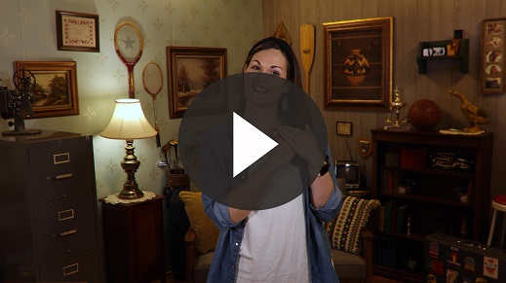
2 Corinthians 5:7 (NLT)
For we live by believing and not by seeing.
Even if we can’t see God, we can believe in God because of all of the great things He has done for us. We know He loves us and has a plan for our lives.

Prayer and Response
Consider playing a worship song softly in the background while kids pray.
Did you know that God even knew you were going to be here today? He has a plan for your life and knows what is best for you. Maybe you are here to understand something you are going through. Maybe you are here because someday God is going to use you to help someone else, and you need to be ready.
Salvation Prayer
You could be here to learn about a God who loves you and does crazy things to save the people He loves. God knows what’s best. The best thing that could ever happen in your life is having a relationship with God. Jesus came to earth and died so we could have a relationship with God and one day be with Him in heaven. If you have never prayed to have a relationship with God, this is your time. God planned for you to hear this today. Right now, we are going to pause in case you need to make a choice to ask forgiveness of your mistakes, or sins, and become a Christian. Just say this prayer after me.

Jesus, thank You for loving me. Thank You for dying for me and coming back to life. Please forgive me for the wrong things I’ve done. I want to obey and follow You. Thank You, Jesus. I love You. Amen.

You are now part of God’s family! You have a relationship with God, and can ask Him for help whenever you need it. You probably had no idea what was going to happen today, but God knows what’s best.
• Give kids time to pray. Then introduce the worship song. This could play in the background while the kids pray or could be a worship song to sing together.
Worship Song
Play a worship song.
Video Wrap-Up
Before we go to our small group activities, let’s see how the Challenge Accepted team is handling their challenge.
• Play Bible Lesson Video B.
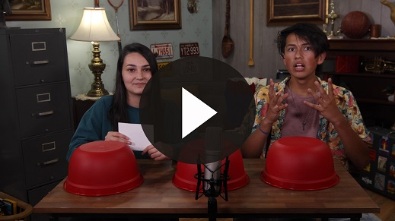
Let’s all accept the challenge that Carington gave us and find all the ways God was moving behind the scenes in Esther’s story. Let’s trust that God has everything under control and knows what is best for each of us. Let’s say our Faith Fact together again.
• Show the Faith Fact Slide.
Say it with me. God knows what’s best. Even when nothing makes sense in my life, I know that God is working it all out for me. Let’s say it one more time together. God knows what’s best.
• Dismiss kids to Small Group time or to go home if your group time ends here.

Small Group
30 Minutes
This section can be done in conjunction with the large group, or on its own if you do small groups with your kids. During Small Group time, the goal is to connect the kids with the Word of God and to each other. All activities are led by the small group leader.

Group Connection
Secret Message
You Will Need
- Small Group Group Connection one puzzle per kid
- Pencils or pens, one per kids
Getting Ready
- Print the Small Group Group Connection page, one puzzle per kid.

Esther and Mordecai had to send messages back and forth. Here is a message that you will have to decode using this decoder. Once you finish, share the message with a leader to see if you cracked the code!
• If you have kids that don’t read yet or struggle with reading, you can have them work in groups to break the code.
Great job on sending the message! Now let’s go to our Bibles to read the rest of what happened between Esther and Mordecai.

Bible Lesson Recap
You Will Need
- Bible, one per kid

No prep needed for this activity.

Bible Story Review: Esther 4:10 to 5:4
• Divide the Bible reading into smaller chunks for kids to read aloud.
Earlier we acted out the story, which was a lot of fun. Let’s look a little closer at our story today by reading the story in the Bible. Haman has convinced King Xerxes to sign a law to kill the Jews, not knowing that Queen Esther was also a Jew. Mordecai found out and lets Esther know what is happening.
Sometimes reading through the story helps some of it make sense. Esther had prayed and had faith to go before the king, even though she wasn’t invited to go to him. She could have been killed, but God knows what’s best. God took care of her and gave her great favor with the king.
Faith Fact
Speaking of faith, why don’t we look at our Faith Fact again and say it together.
• Show the Faith Fact Slide.
God knows what’s best.

Group Discussion
Feel free to use all or just a few questions as a jumping-off place for good discussion. Questions marked with * are designed for more conversation. Adjust the questions based on the age or maturity of your group. Typically, older kids will be able to dive a little deeper than younger ones.
Questions
Today, we learned that God knows what’s best. How do we see this truth in our story today?
Even though Esther was queen, could she go to visit the king whenever she wanted? What was needed in order for her to see the king?
What would have happened to the Jews if Esther had done nothing? What can we learn from this?
* Esther never asked to be a hero or save a nation. Mordecai knew that she was the only one who could do it. Have you ever felt like you have been asked to do things that you didn’t want to do, but you had to do it to help someone else? Tell us about it.
Sometimes it is hard to ask other people to do things that puts them in danger. How do you think Mordecai felt putting his cousin at risk? How would you feel?
What happened when the king saw the queen? What does this tell you about the way he felt toward Esther?
How do you think Haman felt being invited to the banquet? Why do you think Esther invited him even though he was the one trying to kill the Jewish people?
In the end, the king gave his queen and all of the Jews a way to survive. God once again saved His people. If Esther had not been queen, things could have gone completely different. Can you think of any other times in the Bible that God used someone to save the Jews?
* Jesus died for us so that we could be forgiven for the wrong things we’ve done and have a relationship with God. Although we don’t always know what is going to happen in the future, we know that God has a plan for us. Read Esther 4:14 again. What does this verse mean to you?

Application and Response
God has a plan for each of our lives. I have to trust Him and listen to whatever He asks. I can find that plan by praying, reading my Bible, and being around other Christians who encourage and teach me, like we are doing right now.
Make It a Habit
Select a simple visual reminder of the session’s Faith Fact.
We want to make sure a lesson as important as we learned about today is not something that we forget. This week when you wonder, “Why am I here?” or “What is my purpose?” look up to heaven and remember that God knows what’s best.
Prayer
Let’s pray and ask God to help us.
Father God, thank You for reminding me that You have a plan for my life. I know that I can trust You and do as You ask no matter what may happen. Thank You that You know what is best in every situation. Amen.

Faith Verse Review
You Will Need
- Small Group Faith Verse Review, one set per pair
- Scissors
- Plastic sandwich bags, one per pair
Getting Ready
- Print and cut apart the words on the Small Group Faith Verse Review, one set per pair.
- Place each set of words in a plastic sandwich bag.

Our Faith Verse is 2 Corinthians 5:7. To truly believe that God knows what’s best, we have to have faith. Our Faith Verse helps us understand what faith is. Let’s say the Faith Verse and do the actions for the verse together.
• Show the Faith Verse Slide.
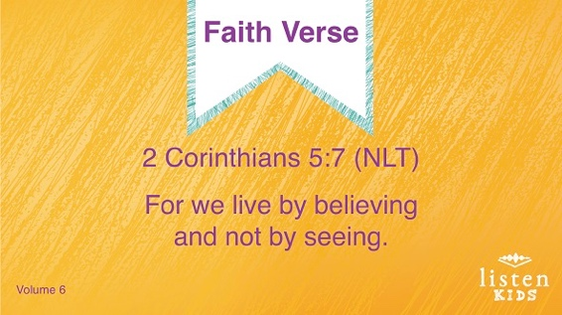
2 Corinthians 5:7 (NLT)
For we live by believing and not by seeing.
Faith Verse Fun
What’s Best
I am so proud of you, that was great! Today, we have all of the words from our Faith Verse on pieces of paper in these plastic bags. Everybody get into pairs. You will race to see which pair can put their Faith Verse in order the fastest. But the name of this game is “What’s Best?” In the plastic bag of papers, there will also be words that are not part of the verse. You have to choose which words are the correct ones, which ones are best, and put them in order correctly. Are you ready for this challenge?
You guys were able to find the right words and put them in order correctly. You were able to determine which words were best to complete our Faith Verse. Great job!
2 Corinthians 5:7 (NLT)
For we live by believing and not by seeing.

Creative Activity
Character Search
You Will Need
- Small Group Activity Page, one per kid
- Pens or pencils, one per kid
Getting Ready
- Print the Small Group Activity Page, one per kid.

Let’s complete our word search.
Prayer
Dear God, thank You for having a plan for my life and always knowing what is best for me and for where I live. Thank You that Jesus has prepared a way for me. Amen.

Faith Fact Recap
• Display the Faith Fact Slide as parents are coming into the room.
• Maximize the time you have with your kids, so that parents see what their kids have learned. Have the kids repeat the Faith Fact, and then dismiss them to their parents.
One of the important things we all need to remember from today is our Faith Fact.
• Show the Faith Fact Slide.
Let’s say it together: God knows what’s best.

Dismissal
• Send home the Small Group Activity Page and the Group Connection puzzle.
• Remind parents that there are Family Devotions available on the app to do with their kid.
• Tell everyone the date and time for the next session.

